**Methodology Document**

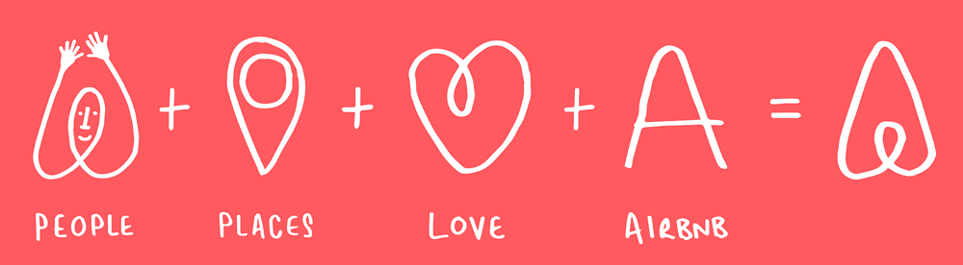

**Storytelling Case Study:**

**Airbnb, NYC**

**Submitted By: Darshika Singh & Satyam Khorgade**

**1.Research Problem**

* For the past few months, Airbnb business has seen a significant decline in revenue due to travel restrictions because of the Covid-19 pandemic.
* The revenue took the largest hit in NYC in the Q2 of 2020.
* Now that the restrictions have started lifting and people have started traveling, Airbnb wants to make sure it is fully prepared for the change.

**2.Objectives**

* Improve our strategies to revive the impact of Covid-19 on the economic
* and market conditions of Airbnb, NYC.
* Understand the customer preference and user experience trends for Airbnb, NYC.
* Provide recommendations for new acquisitions and improve customer experience.

**3.Data Assumptions**

* Assumed that the data prior to the Covid-19 period was achieving the desired goals.
* Airbnb wants to continue its business in NYC and has no plans of expanding to other territories.
* The strategies decided were considered keeping in mind that there will be no further travel restrictions.

**4.Data Methodology**

* Tools used –

Python and Python libraries, for visualization Tableau is used.

* Data Understanding and Preparation:
* The following relevant libraries were imported.

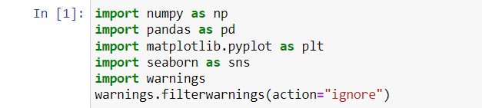

* The dataset was loaded, datatypes of variables were checked and along with that the dimensions and size of the data frame was checked.

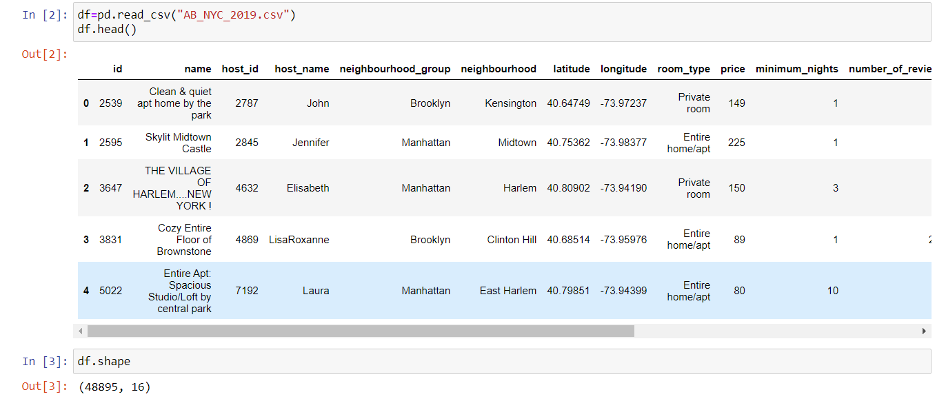

* Handling Missing Values and Outliers:
  + The missing values and outliers were checked in the data frame.
  + The following columns had missing values - last_review, reviews_per_month, host_name, and name.
  + These columns had NaN values - last_review and reviews_per_month indicating some listed properties didn’t receive reviews.
  + Missing values are imputed accordingly with median and mode.

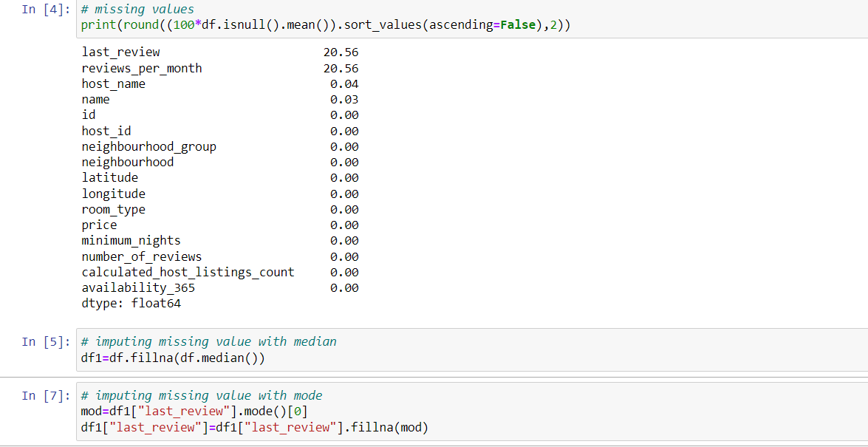

* The following columns had outliers - price, minimum_nights, number_ of_reviews, reviews_per_month, and calculated_host_listings_count and it was treated using capping.

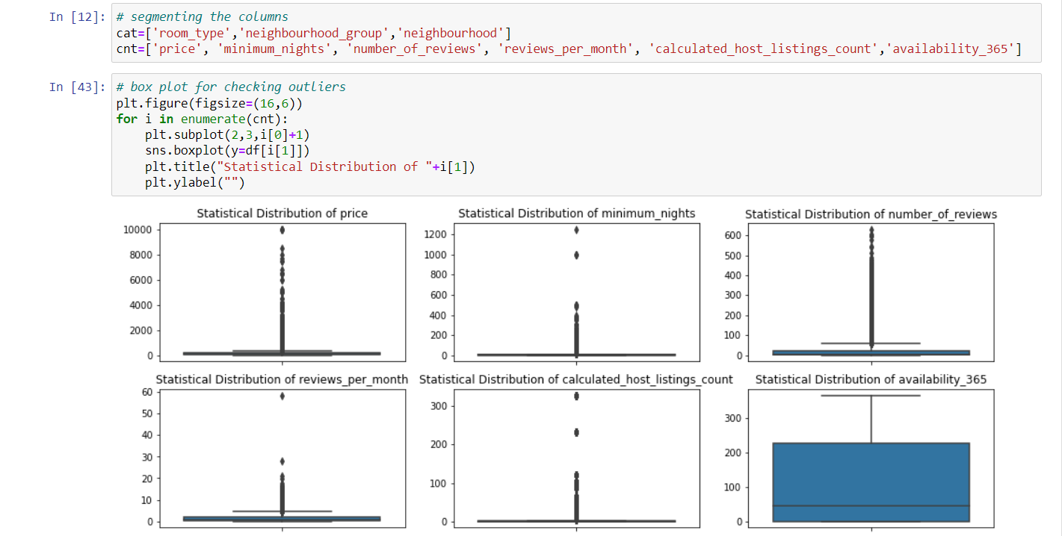

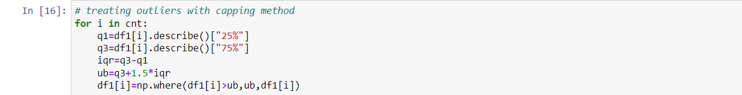

* Loading the data to csv file for further visualization in tableau.

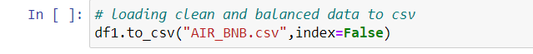

**5. Data Analysis:**

* Scatter plot to see neighbourhood group along latitude and longitude.

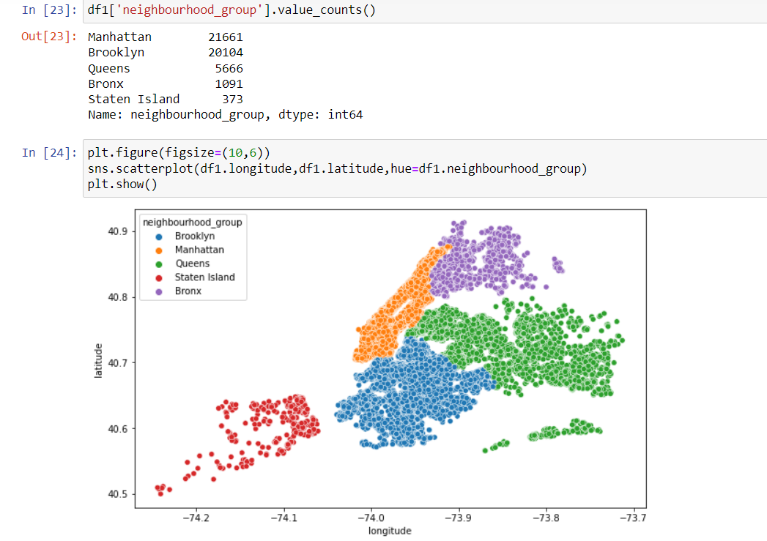

* Scatter plot to see room_type along latitude and longitude.

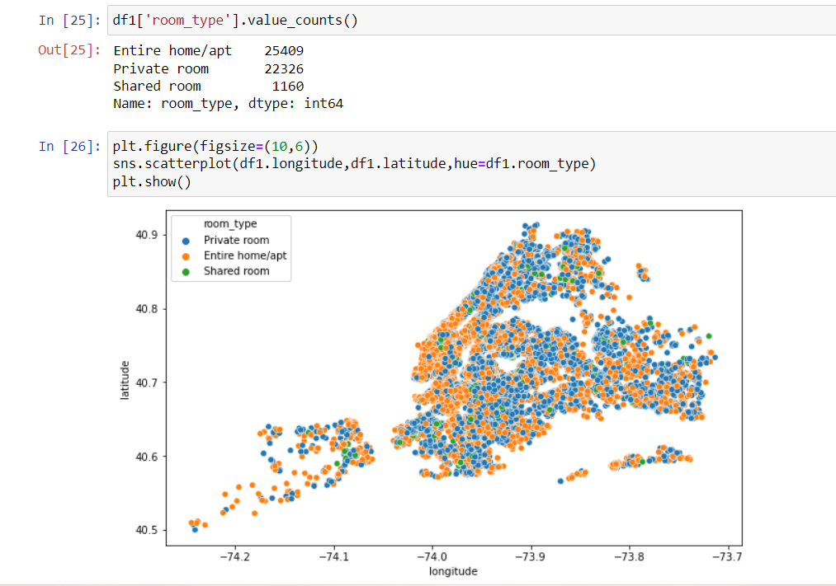

* Violin plot to see price distribution.

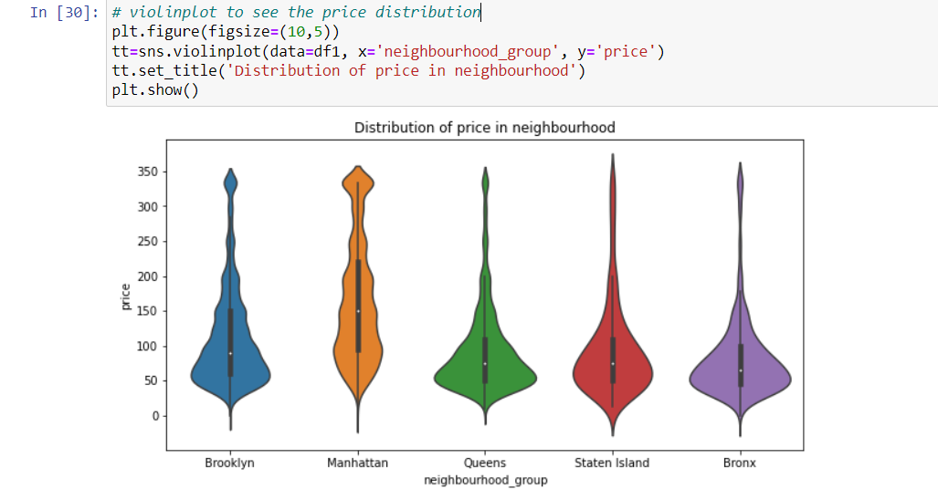

* Correlation between continuous variables can also be seen.

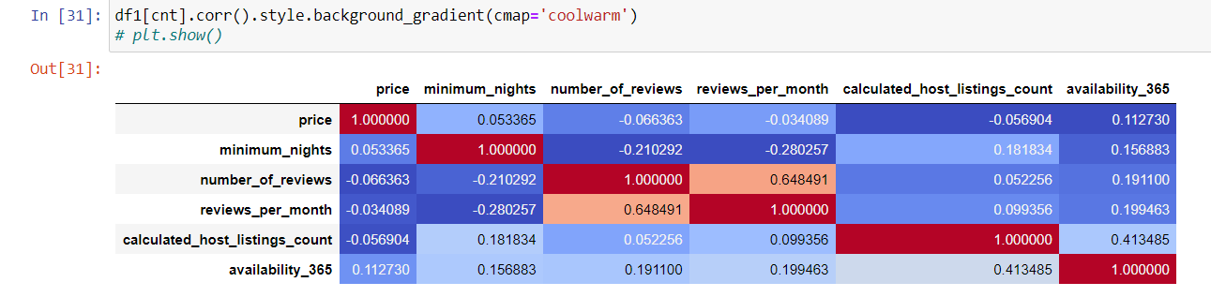

* **6.DATA VIZUALISATIONS**
* **Further Visualisation’s were created in Tableau**
* **Neighbourhood wise Hosts and Most Listings**

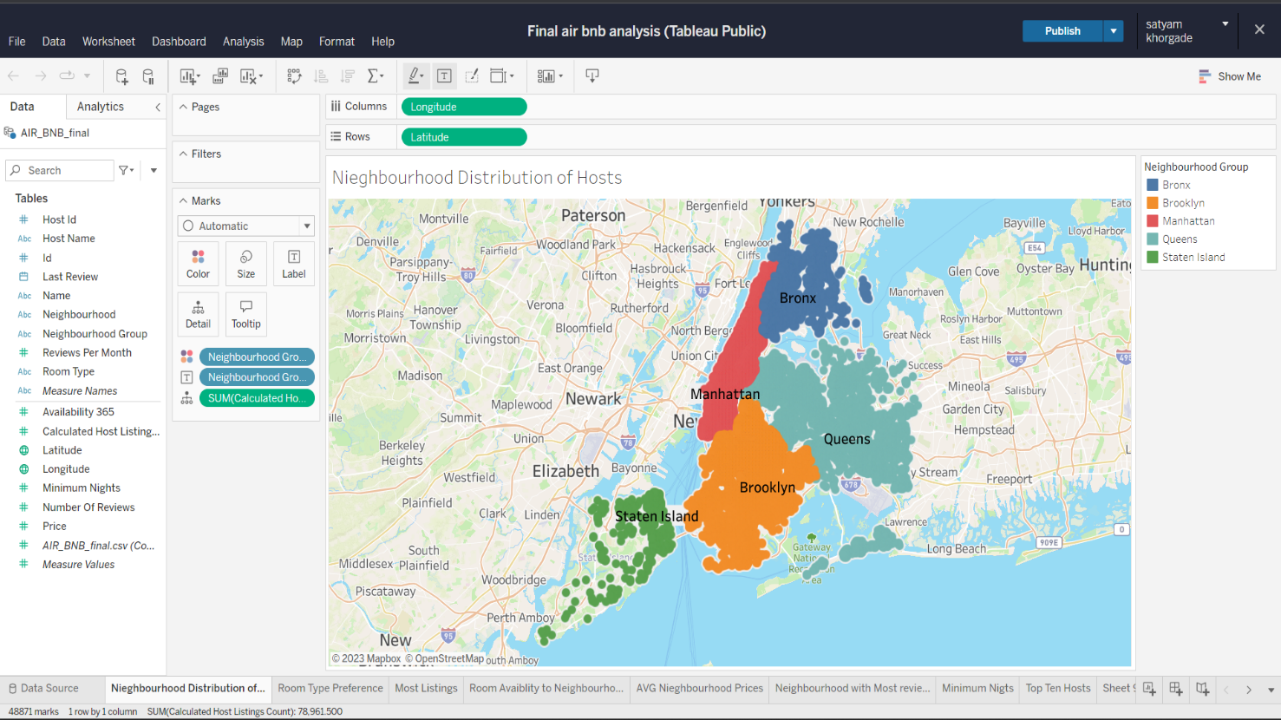

Here we can see the area of neighbourhoods in New York

* **Neighbourhoods with Most Listings**

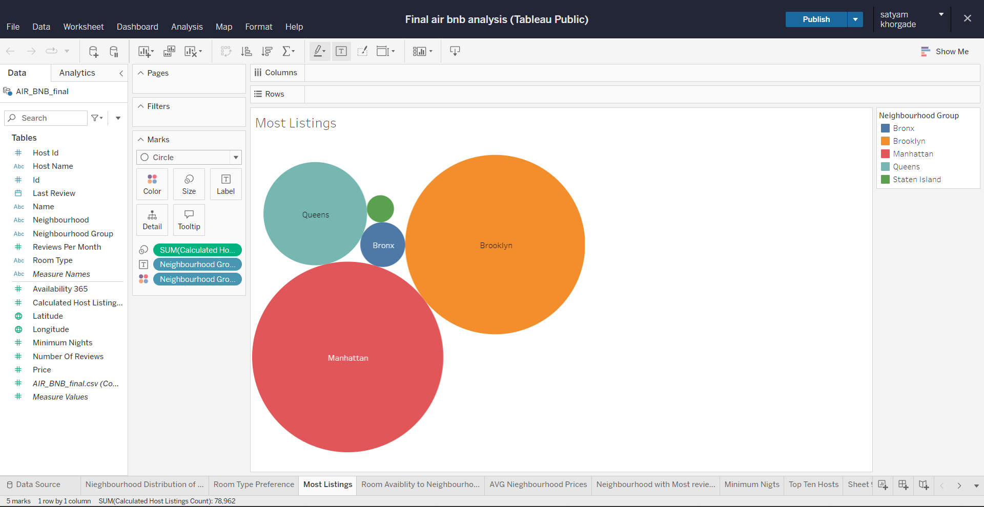We observe most listings are in Manhattan and Brooklyn

* **Room Preference**

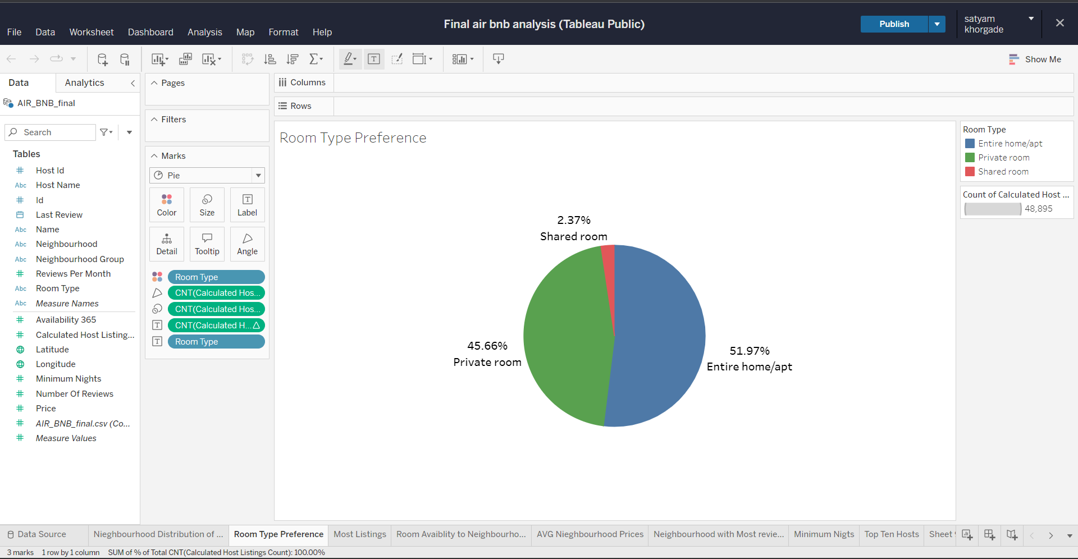People prefer entire home and apartment followed by private room and shared room are least preferred

* **Neighbourhood Availability to room types**

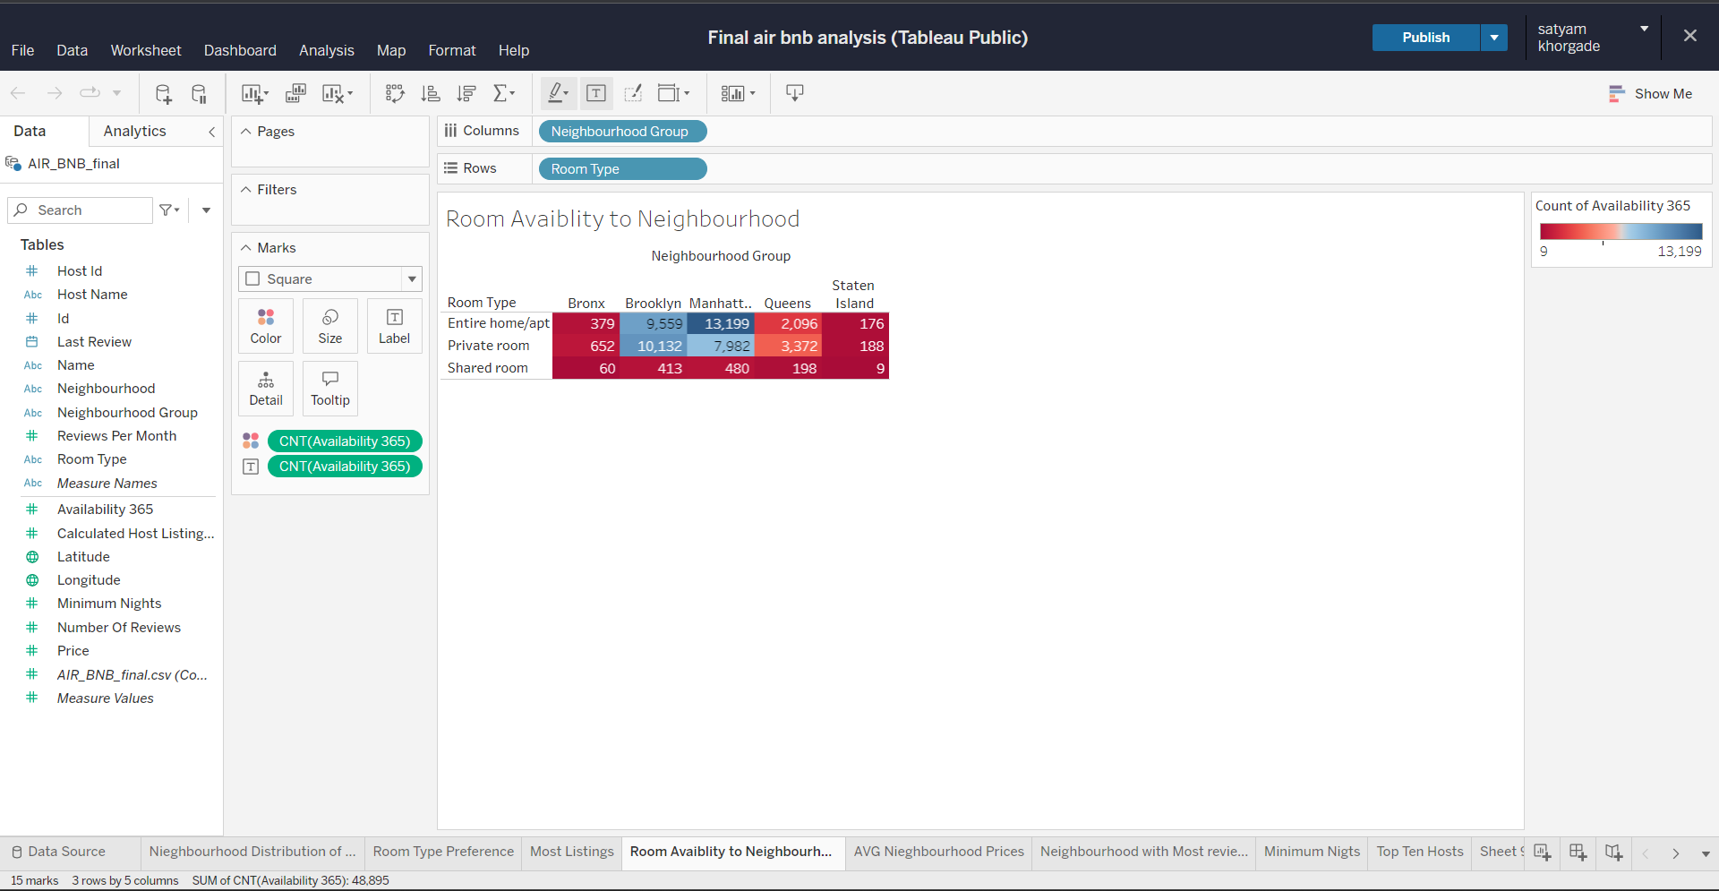

People prefer entire home in Manhattan and private room in Brooklyn

And shared room are not preferred much

* **Average Neighbourhood Prices**

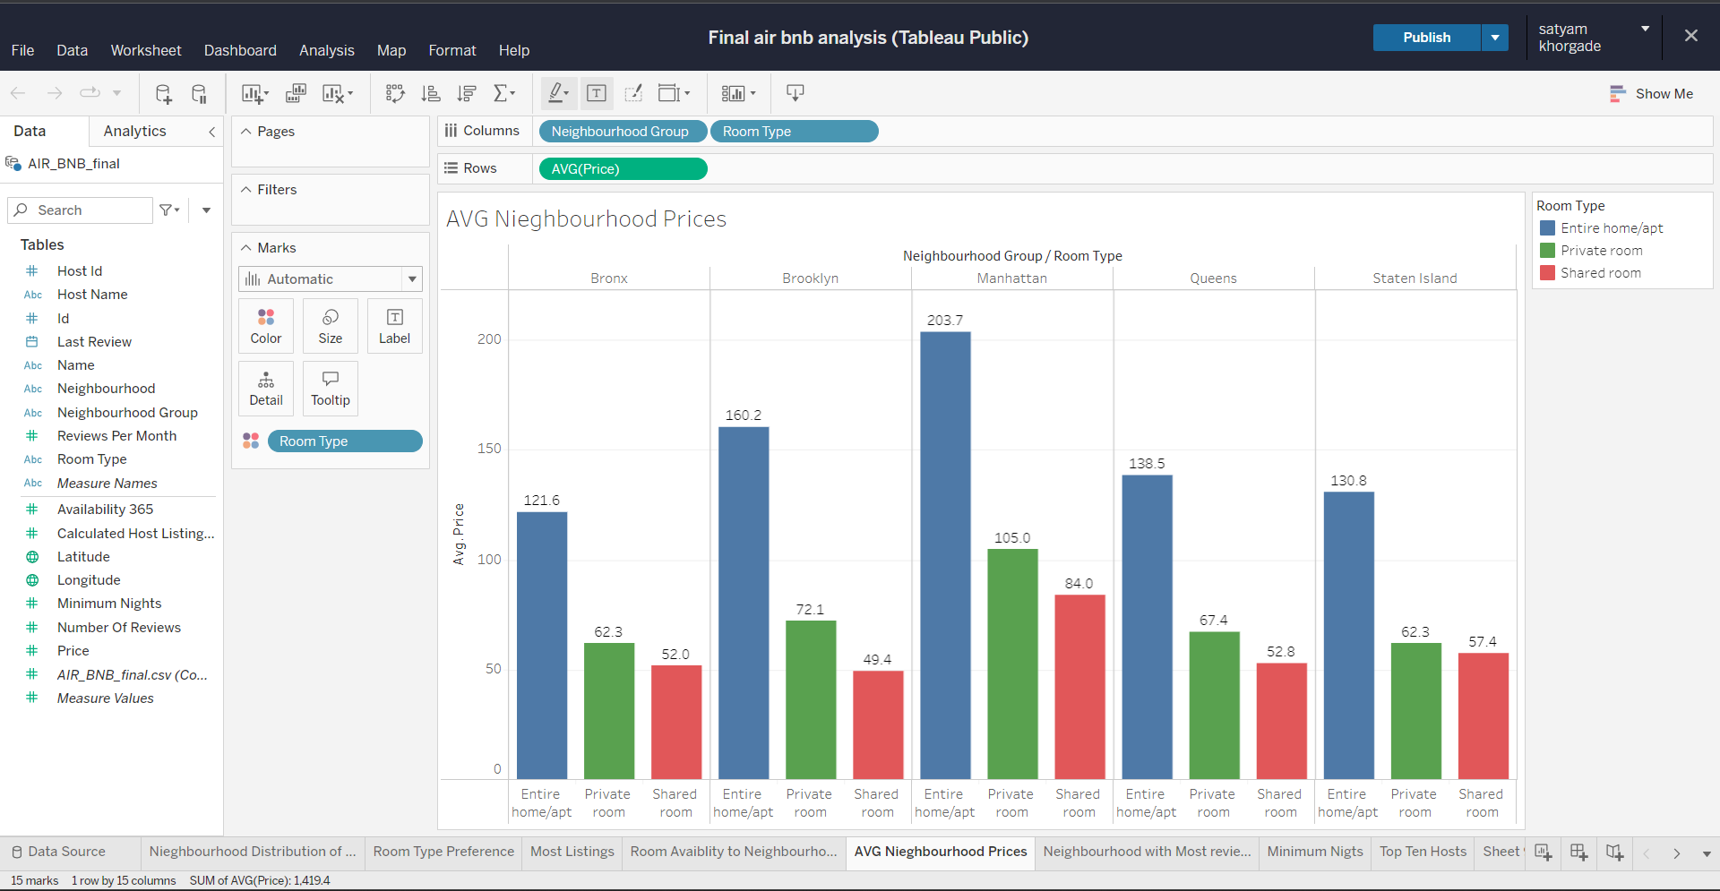

We Observe prices are very high in Manhattan and Brooklyn

* **Top Ten Hosts**

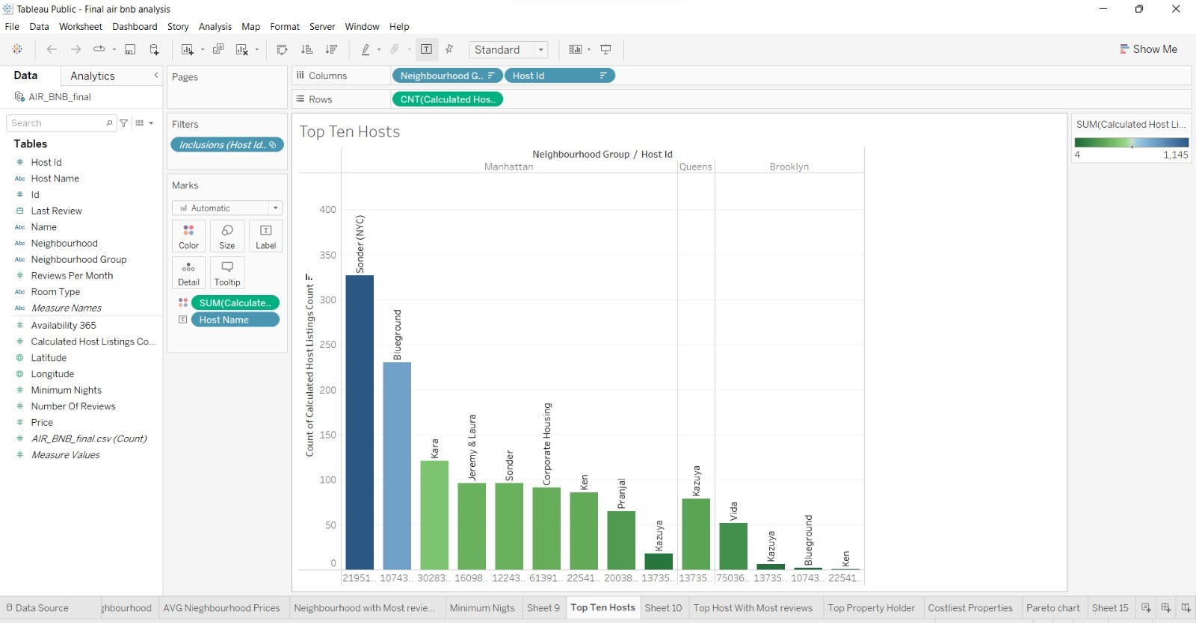

Most host with highest listings is in Manhattan

* **Most Reviewed Hosts**

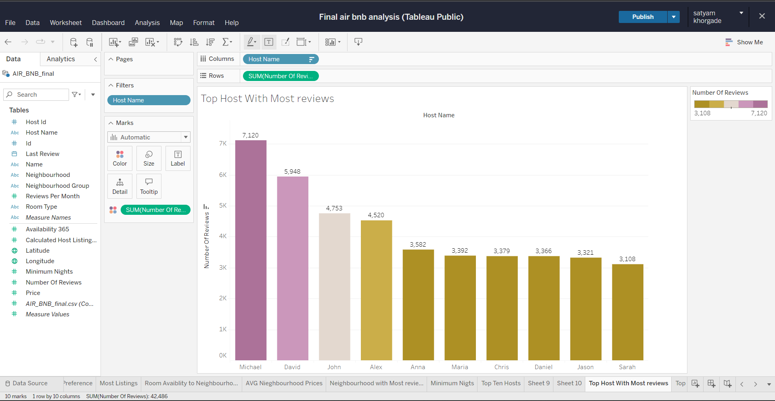

Michael is most reviewed hots followed by David and john

* **Minimum Nights Stayed**

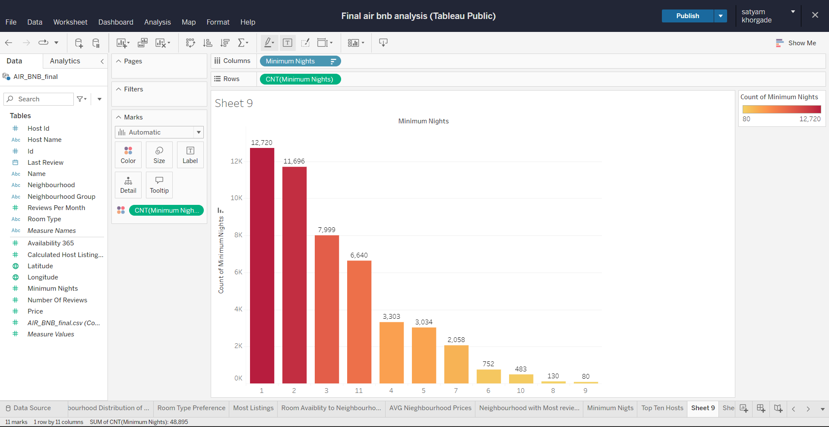

People prefers to stay for minimum one to three days

* **Average Minimum Nights**

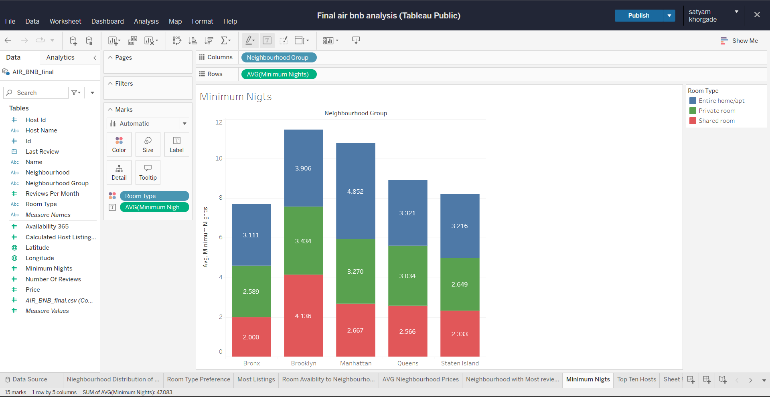

For entire home and apt Manhattan is highest for private room and shared room Brooklyn is highest

**6.Key Insights and Recommendations:**

* Renters in New York City who use Airbnb are privileged entire house or apartment, plus private room above shared rooms.
* Manhattan has the most expensive rental properties followed by Brooklyn, while Bronx and Staten Island have the least expensive.
* People show interest in the host Sonder and spend most nights here.
* Pay attention to popular areas like Manhattan and Brooklyn where more people are interested.
* Since there is a lower likelihood that people will choose a high-priced room, there are more evaluations at lower prices than at higher prices.
* People show interest in the host Sounder and spend more nights there also Michael is most reviewed host among all.
* Majority of the people like to spend one day followed by two days